EE3011.ELECTRONICS 1

EXPERIMENT 3 LAB REPORT
(Section 1)

Mehmet Akif Türkmenoğlu
150720061

Part (1): Diode IV Characteristics
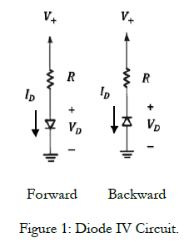
I created the circuit in LTSpice. We used 1N4148 type diode instead of 1N4001 because lab instructor said that its working. Then I created DC Sweep function and record the response of the circuits. I implemented the simulation for 3 resistor values as 1 kΩ, 10 kΩ and 100 kΩ respectively. Then I replied this for the diode which located backward in the circuit. I showed the corresponding current values in the cursor above.

Part (1.1): Forward Bias - 1 kΩ Resistor

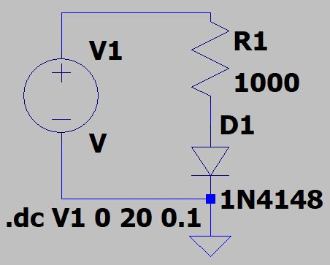

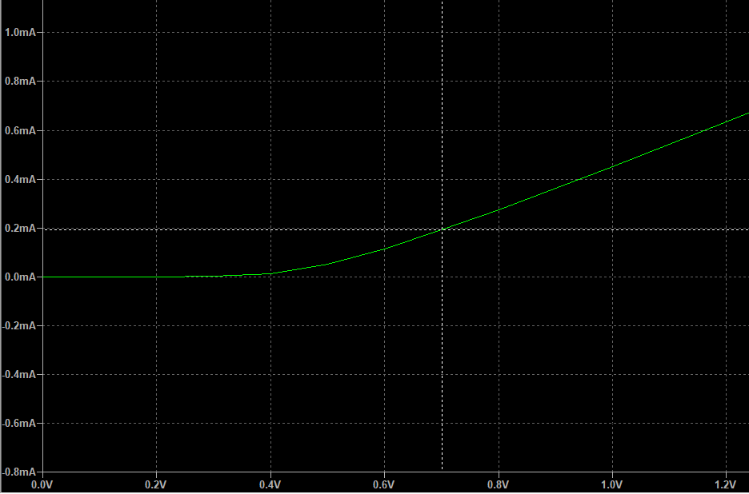

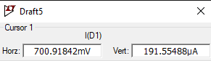

Part (1.2): Forward Bias - 10 kΩ Resistor

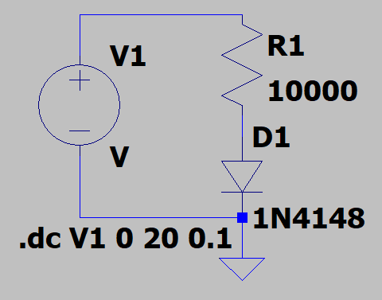

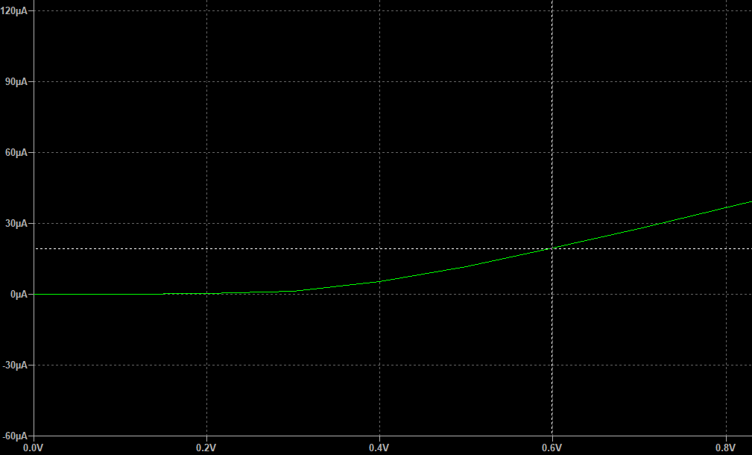

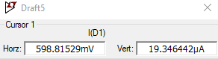

Part (1.3): Forward Bias - 100 kΩ Resistor

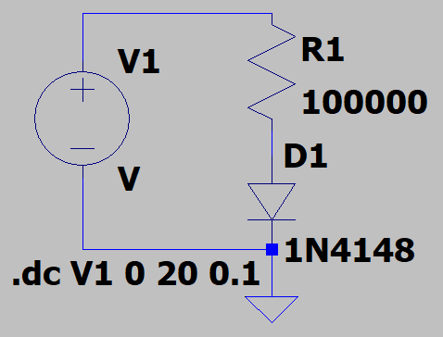
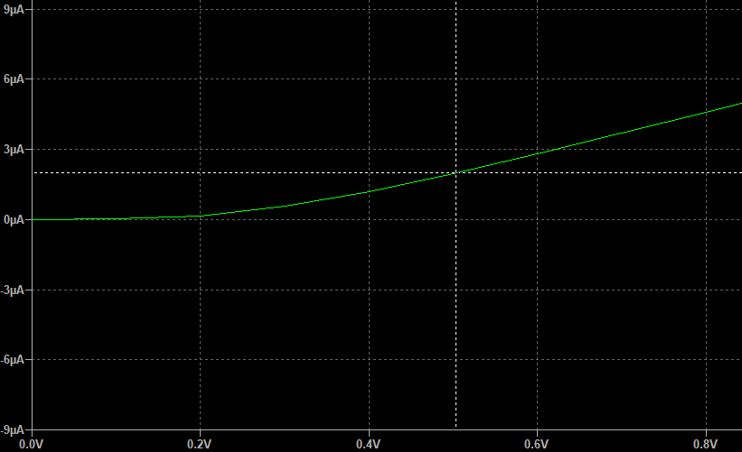

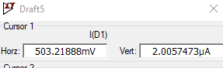

Part (1.4): Results and Analysis

𝑅 (kΩ) | Simulation 𝑉_{DO} (V) | Data sheet 𝑉_{DO} (V) | Simulation 𝑉_{ZO} (V) | Data sheet 𝑉_{ZO} (V)
100 | 700.91 mV | 0.7 V | 172.3 mV | 0.7 V
10 | 598.81 mV | 0.7 V | 172.3 mV | 0.7 V
1 | 203.22 mV | 0.7 V | 172.3 mV | 0.7 V
Table 1. Diode IV Curve.

1. Comment on the results in table 1.

I take the V_{DO} values at the time the line starting to goes up. It may differs about where I specify that curve but they have error in mV. And at the datasheet, we know that the V_{DO} is equal to 0.7 V which is 700 mV. So I can say there is no much difference.

2. Do the IV curves that you obtained resemble the standard diode characteristics?

IV curves form exponentially and my graphs fit that definiton.

Part (1.5): Reversed Bias - 1 kΩ Resistor

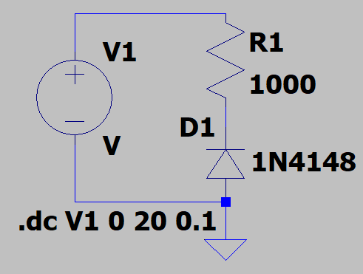

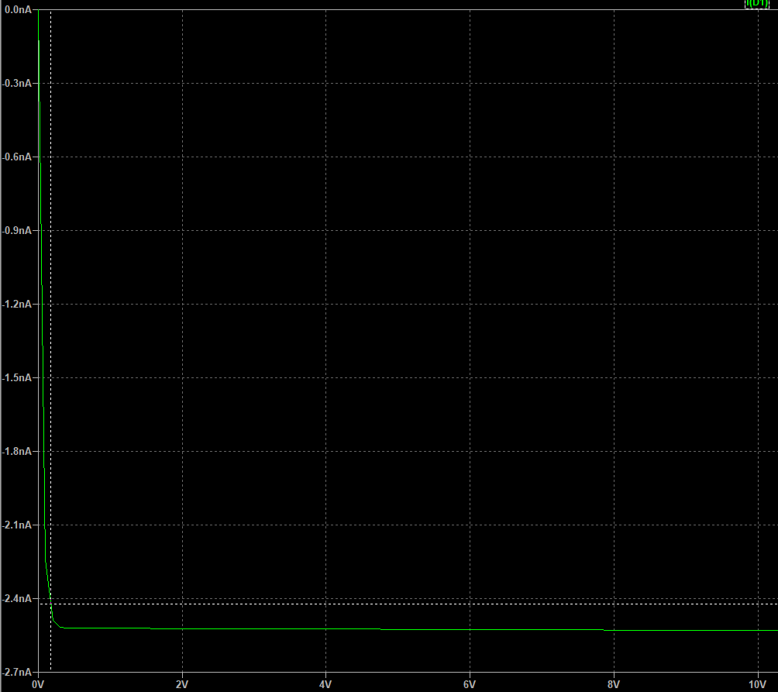

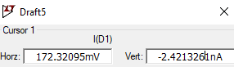

Part (1.6): Reversed Bias - 10 kΩ Resistor

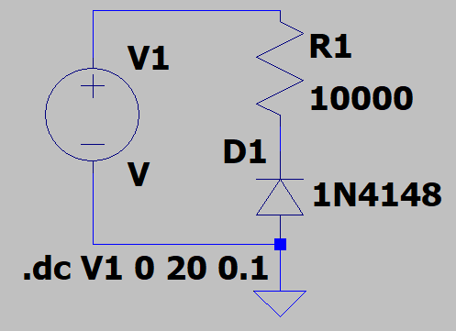

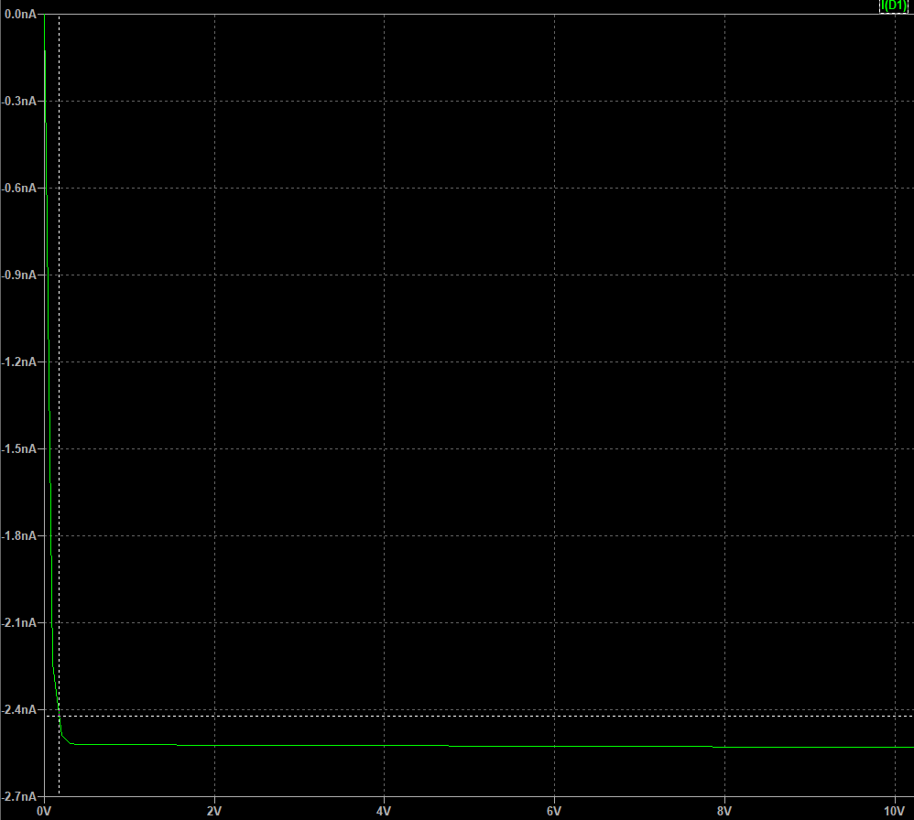

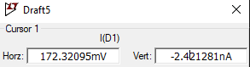

Part (1.6): Reversed Bias - 10 kΩ Resistor

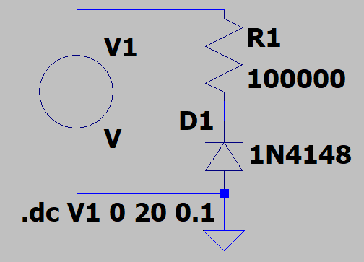

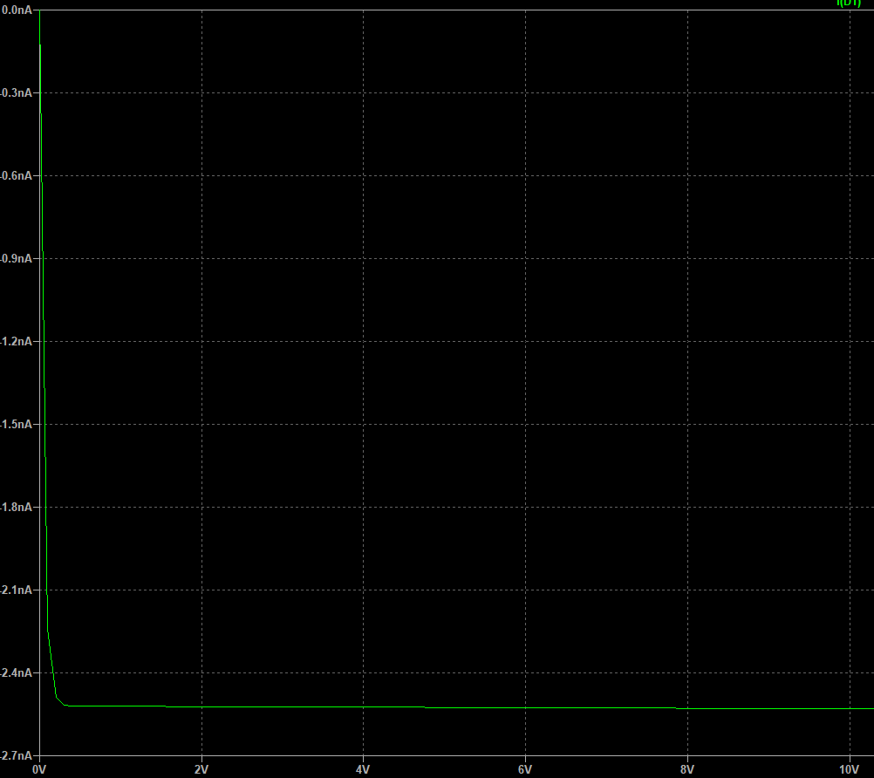

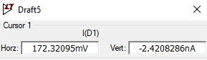

Part (2): DC Diode Circuit

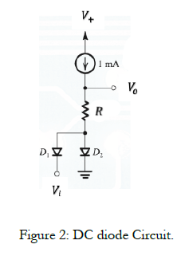
D₁ is connected to V_{i} 10 V voltage source and for D₁ p<n. So diode 1 must be OFF. Other diode D₂ is connected to ground so obviously p>n. This means diode 2 must be ON. According to this setup, I change the R values and simulate the circuit.

Part (2.1): 1 Ω Resistor

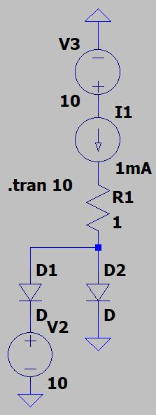

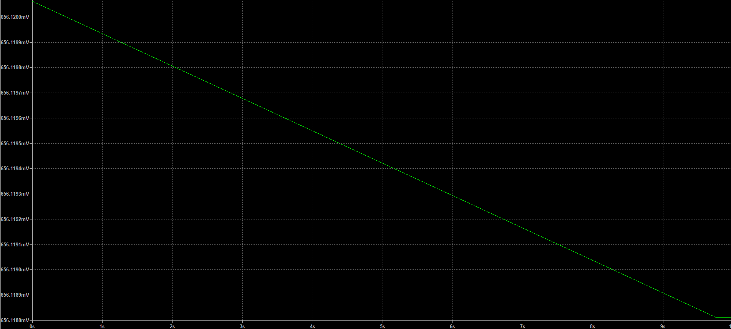

Part (2.2): 10 Ω Resistor

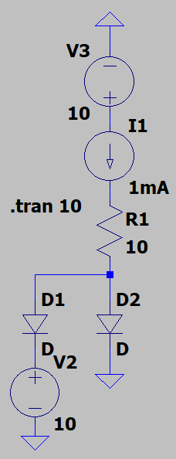

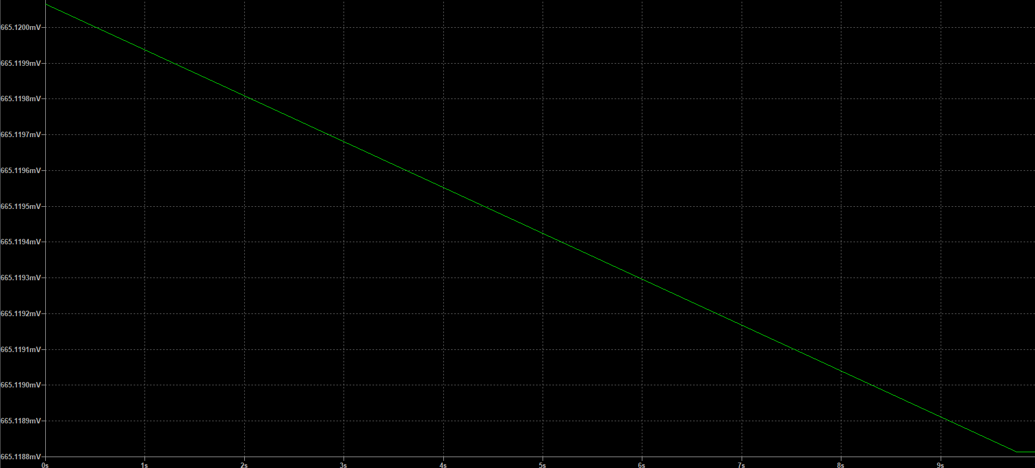

Part (2.3): 100 Ω Resistor

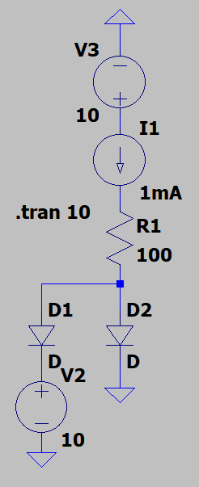

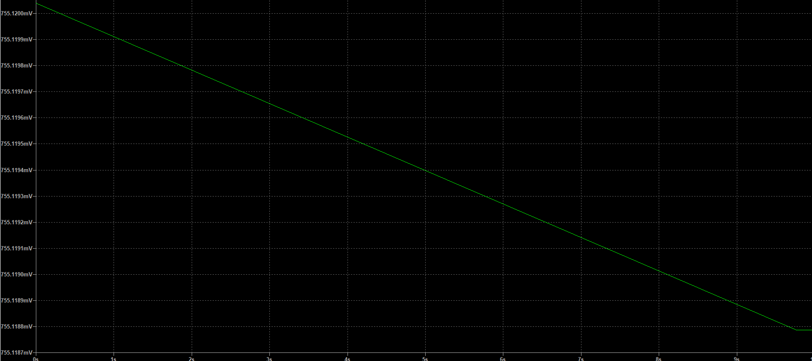

Part (2.4): 1000 Ω Resistor

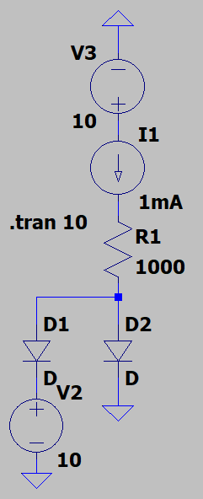

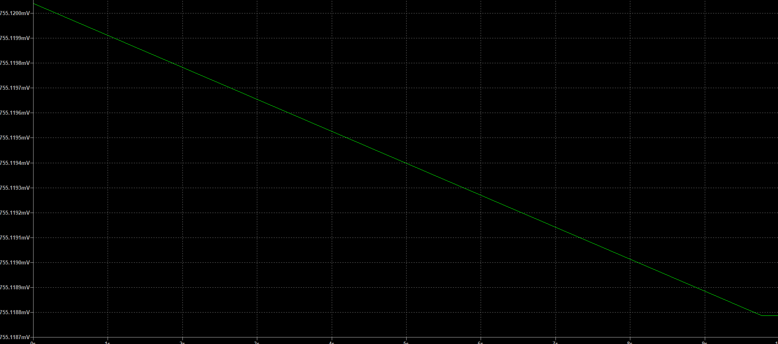

Part (2.5): V_{i} = - 10 V, R Fixed

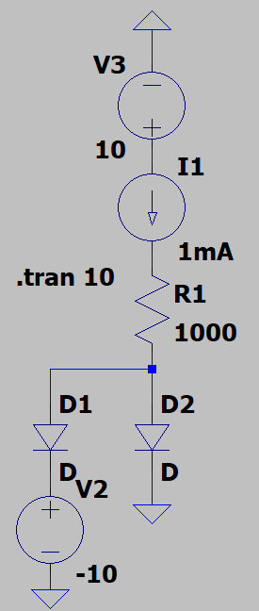

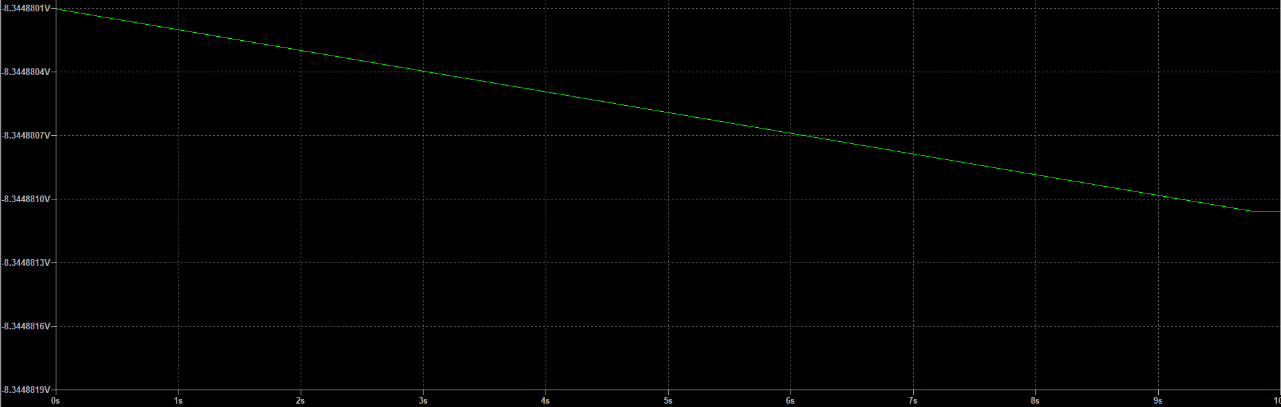

Part (2.6): V_{i} = 10 V, R Fixed

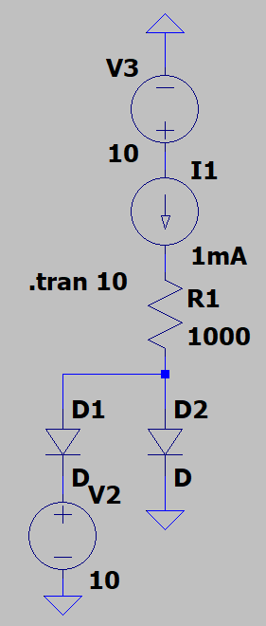

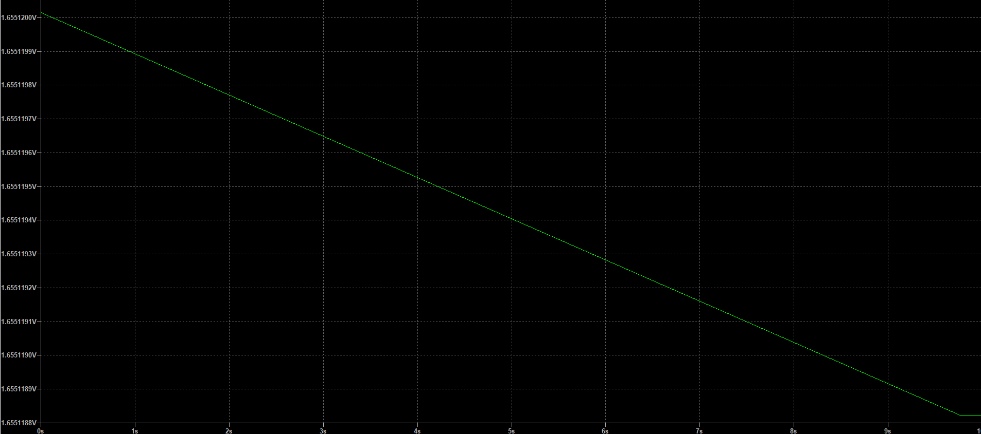

Part (2.7): Results and Analysis

𝑅 (kΩ) | Diode 1  (ON/OFF) | Diode 2  (ON/OFF) | 𝑉₀ (V)
1Ω | OFF | ON | 656.12 mV
10Ω | OFF | ON | 656.12 mV
100Ω | OFF | ON | 755.12 mV
1000Ω | OFF | ON | 755.12 mV

Table 2. Simulated DC results.

- Comment on the results in table 2.

When resistor value increases the V₀ value increases. But changing the resistor is not affecting that much.

- Comment of the output characteristics curve.

Resultant graphs are more like a linear line. It decreases to a specific voltage value and then stays same there.

Part (3): AC Diode Circuit

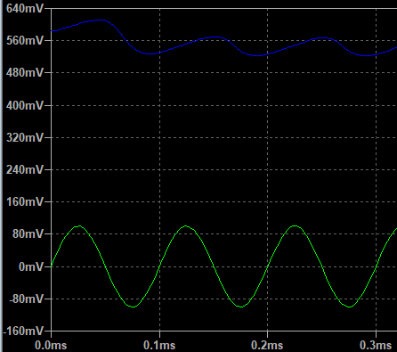
Şekil 1. 1mA - Vi and V0
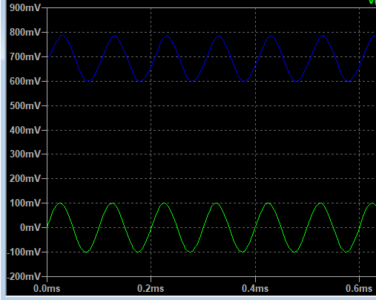
Şekil 2. 10mA - Vi and V0

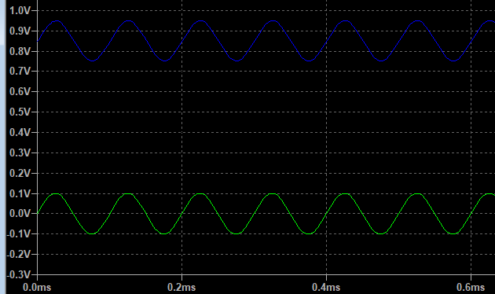
Şekil 3. 100mA - Vi and V0
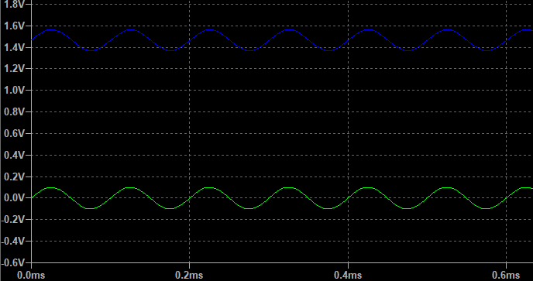
Şekil 4. 1A - Vi and V0

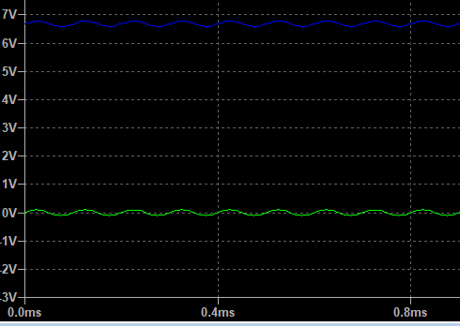
Şekil 5. 10A - Vi and V0

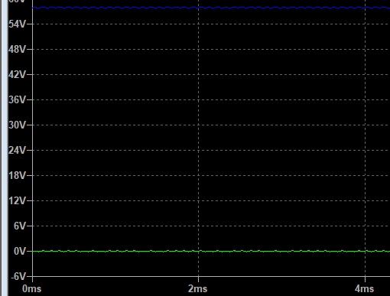
Şekil 6. 100A - Vi and V0

When I look at the graphs of V_{i} and V₀, it looks identical. I changed the I values but they are also same for all currents.

I | Phase shift
1 mA | 0
10 mA | 0
100 mA | 0
1 A | 0
10 A | 0
100 A | 0
Table 3. Simulated AC results.

1. Which value of 𝐼 gives a phase shift of ±45o?

No value gives us phase shift of 45⁰. I know that when I change the phase of sinusoidal voltage source, maybe I can see the difference in simulation but I doesn’t affect the phase shift I guess.

2. Explain the output waveform.

Output waveform is sinusoidal. V_{i} has bigger amplitude.
3. Comment on the circuit output characteristics curve.
When I increases, the frequency of sinusoidals increase too.

Lab Assignment
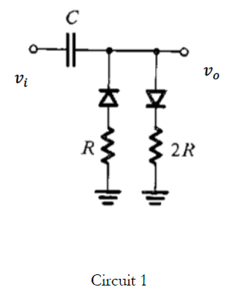
Lab instructor didn’t give us any circuit but I choose circuit 1 to do. The values of capacitor and resistor are chosen by me. And I want to remind that I used 1N4148 rather than 1N4001 diode. I created the circuit and simulate.
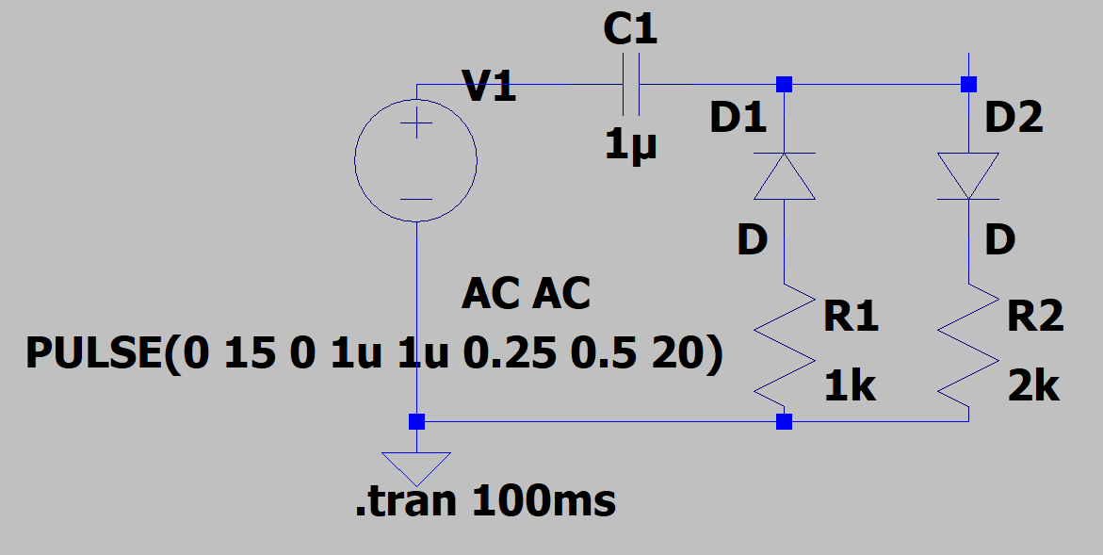
Here is the output waveform of V₀:
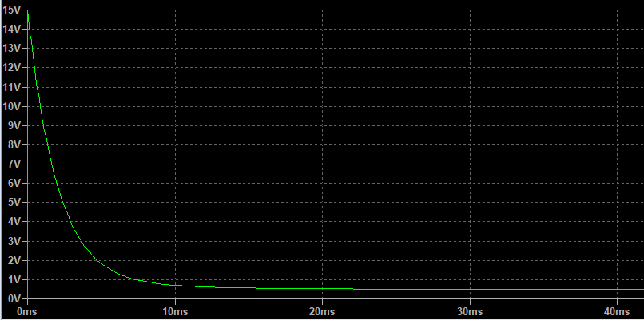

This is the output waveform of V₀ at period 0.1 :
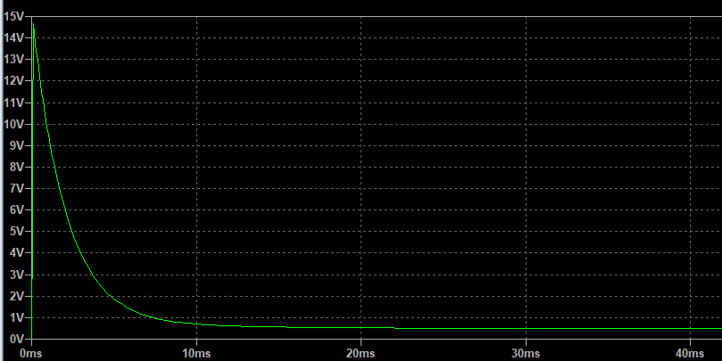

This is the output waveform of V₀ at period 10 :
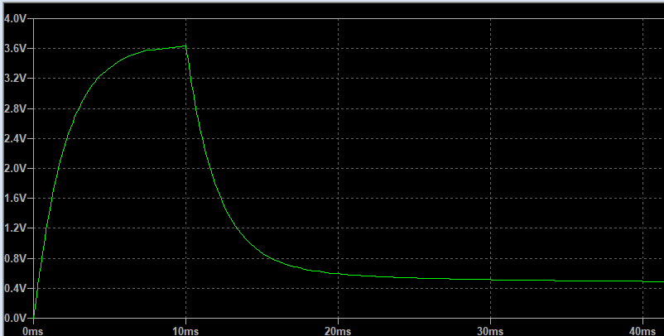

When I increase the two of the resistor value (R=5kΩ), the output waveform changed as this:
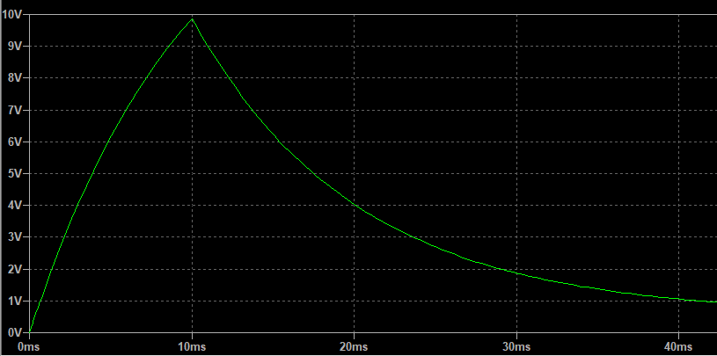

When I change the capacitor value to 100u, output waveform changed as this:
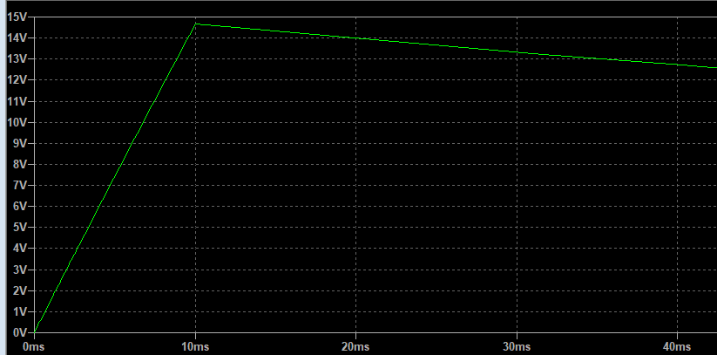

I think that this is useful for digital implementations because we can represent the high voltage values as 1 and low voltage values as 0.

Mehmet Akif Türkmenoğlu
150720061
Section 1

